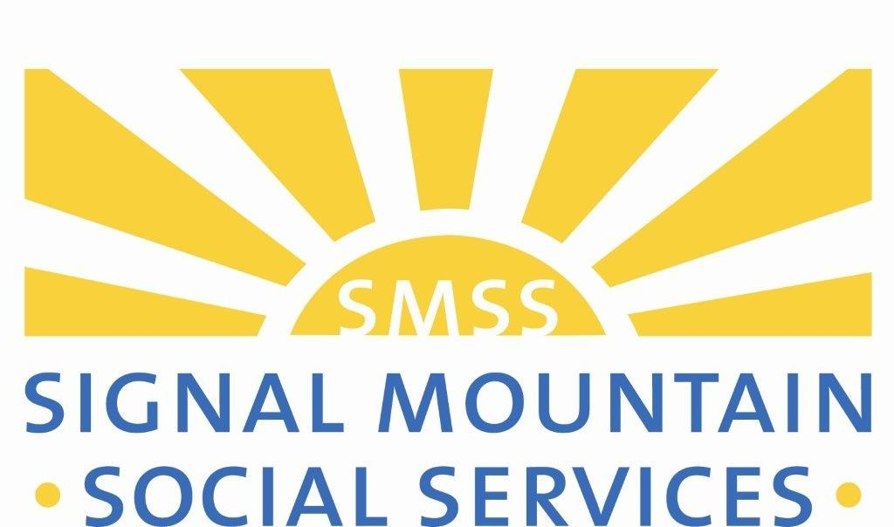

Signal Mountain Social Services Scholarship Renewal Application

**Purpose and History:** Established in 2012, the Signal Mountain Social Services Scholarship Fund provides post secondary scholarships for Signal Mountain traditional and nontraditional students living in the 37377 zip code based on financial need. The scholarship can be used at any not-for-profit, regionally accredited, technical, community or four- year college or university.

# Eligibility Requirements

**- *Student received a scholarship from SMSS within the last 12 months.***

**- *Residency Requirement*:** Resident of Signal Mountain, Tennessee in the 37377 zip code

**- *Education Requirement*:** Current student in good standing at a qualifying postsecondary

institution.

**- *Must have demonstrated financial need for assistance***

**- *Minimum Cumulative GPA:*** 2.5

**- *Volunteer hours were completed as requested for previously awarded SMSS scholarship(s)***

**- *Required documentation of grades were submitted as requested to SMSS for previously awarded SMSS scholarship(s)***

**- *Completed scholarship renewal application with required documentation must be received before the deadline to be considered.***

# Renewal Scholarship Award Amount:

Award amount varies based on a student’s demonstrated financial need, funding availability and academic progress towards graduation. A renewal application must be received with required documentation by the deadline to be considered. Students who do not meet current eligibility requirements will not be considered for a renewal scholarship.

# Application Deadline for Renewal Scholarships

For scholarship awards beginning fall semester apply by **JUNE 1**

For scholarship awards beginning January, apply by **OCTOBER 1**

***Give yourself plenty of time to thoughtfully complete your renewal application, complete your FAFSA, make arrangements for a letter of recommendation to be submitted, and gather other required documentation. Your letter of recommendation, application and required documentation must be received by the deadline. Incomplete applications will not be considered.***

**Signal Mountain Social Services Scholarship Renewal Application**

**DIRECTIONS: *Complete this application only if you are a current SMSS scholarship recipient*.** To apply for a scholarship renewal, answer each question on the application, apply for financial aid through the Free Application for Federal Student Aid (FAFSA) and provide all of the required documentation listed on this application. Complete your FAFSA at https://studentaid.ed.gov/sa/fafsa. There is no cost to complete the FAFSA or to apply for a SMSS scholarship.

If you have questions about this application, need help completing it or need help completing your FAFSA, please contact us at [smss@signalmountainsocialservices.org](mailto:smss@signalmountainsocialservices.org) 423-886-5982.

Be sure to include as much information as possible in your responses to each question. Your financial need and the information you provide on this application have a large impact on scholarship award decisions. If you need additional room for your responses, you may attach additional pages to your application.

# Submit Your Application Package By Mail, In Person, or Email by the Deadline:

|  |  |  |
| --- | --- | --- |
| **Mailing Address**  Signal Mountain Social Services |  | **Submit in Person**, 10AM – Noon, Monday- Friday  Signal Mountain Social Services |
| PO Box 294 | **OR** | 633 Mississippi Ave. |
| Signal Mountain, TN 37377  **Email address: smss@signalmountainsocialservices.**  **org** |  | Signal Mountain, TN 37377 |
| ***APPLICATION CHECKLIST: The following documentation must be included with your application. Incomplete renewal applications will not be considered.*** | | | |
| **Student Aid Index (SAI) and FASFA submission summary**  from your current **¨ Most recent college or program transcript.** Students completed FAFSA. Please print and include the entire may provide a printed copy of the transcript.  report. SAIs from a prior period will not be accepted. | | | |
| **¨ Complete the cost of attendance section on this**  **application.** | | | |
| **¨ Identify income, family contributions, grants, student**  **loans and scholarships you plan to receive this year on**  **your application.** | | | |
| ¨ **Answer all questions on the application and turn in your application packet with supporting**  **documentation by the deadline.** | | | |

**Applicant Information**

Full Name: Date:

*Last First M.I.*

Mailing

Address:

*Street Address Apartment/Unit #*

*City State ZIP Code*

Home

Address:

*Street Address Apartment/Unit #*

*City State ZIP Code*

Phone: Email

Major or Course of Study

Did your major change in the last

12 months?:

University/College or Technical/Vocational

School:

|  |  |  |
| --- | --- | --- |
| Will you be attending a different school for the upcoming semester? | YES | NO |
| Will you be working in the upcoming semesters? | YES | NO |
| Are you currently working? | YES | NO |

Where are you currently working and how many hours a week do you work?

What is your expected graduation date? Will you be a full-time student during the renewal scholarship period? YES NO

Will you be attending as a SOPHOMORE JUNIOR SENIOR N/A

Where will you live while you are attending: ON CAMPUS OFF CAMPUS APARTMENT OTHER (please explain) Please provide the mailing address of where scholarship funds should be sent.

_______________________________________________________

_______________________________________________________

_______________________________________________________

# Progress Towards Graduation

1. If your course of study has changed since your previous scholarship application, please share what influenced this decision? If you are changing schools, please share what factors led you to make this decision.
2. Are there new circumstances we should be aware of as we make scholarship award decisions?
3. What activities, community service, student groups, social groups or pre-professional groups and organizations have you been actively involved with over the last 12 months?
4. Please share one challenge you faced over the last 12 months as you’ve progressed towards graduation and how you faced this challenge.
5. What do you plan to do over the next 12 months that will prepare you for your career and help your resume stand out from other new graduates in your industry?
6. What are your academic goals for the next 12 months?

# Letter of Recommendation

*This application requires a current letter of recommendation from a professor, employer, volunteer supervisor or non-relative who knows your academic ability, character and work ethic well. The letter must be written within 60- days of the renewal application date. We cannot accept a letter of recommendation submitted with a prior SMSS scholarship application.*

*Please request your personal reference submit a dated letter of recommendation directly to SMSS. The letter can be mailed to Signal Mountain Social Services PO Box 294 Signal Mountain, TN 37377 or emailed to* [*smss@signalmountainsocialservices.org*](mailto:smsocialservices@comcast.net)

*To ensure your letter of recommendation is reviewed with your application, please share the following info about your personal reference.*

Full Name: Relationship: email: Phone:

# Expenses and Paying for Education and Living Expenses

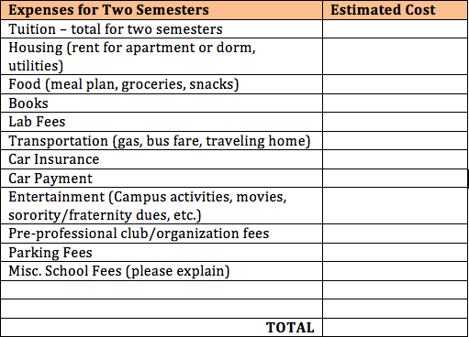Please list your estimated expenses, income, grants, scholarships and family contributions for the upcoming scholarship

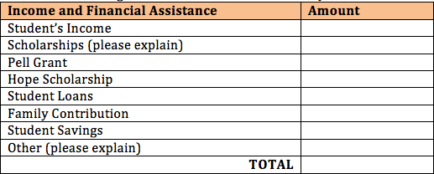

renewal period. Be sure to include further explanation as requested.

# Statement of Accuracy and Cooperation

***I certify all the information provided by me for consideration of a Signal Mountain Social Services Scholarship is true, correct and without forgery.***

***I understand if I am awarded a SMSS scholarship, I agree to volunteer 3-hours per semester for each semester in the scholarship period for a total of 6 hours. Volunteer hours may be completed through SMSS or for a nonprofit community organization I am currently involved with as a volunteer. If awarded a scholarship, I will provide my grades to SMSS as outlined in my scholarship award agreement. I consent that my photo may be taken and used for any purpose by SMSS to promote the SMSS scholarship program.***

***I understand this scholarship is a grant and does not need to be repaid.***

***Signature of Scholarship Applicant Date***

***Witness Date***